**Lab Assignment 6 – Sarveshwaran Sampathkumar**

Display all the courses handled by a Teacher:

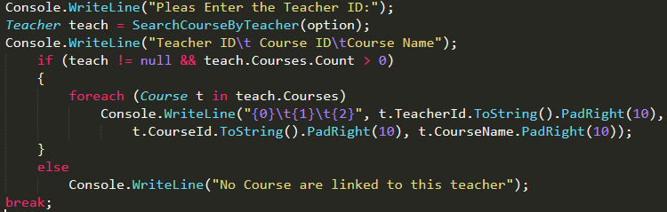

SearchCourseByTeacher Method:

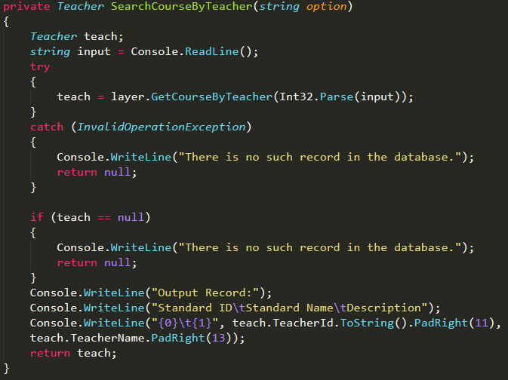

Business Layer:

GetTeacherByName Method:

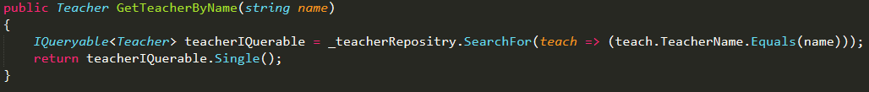

GetCourseByTeacher Method:

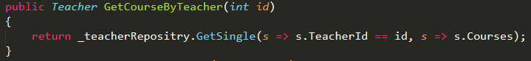

IRepositry Interface

